Predicting Order Profitability
A Machine Learning Classification Model
Week 4 Task – Machine Learning Model Development and Evaluation
Yuva Intern / NSDC Data Analytics Program
Python libraries used: Pandas, NumPy, Scikit-learn, Matplotlib, Seaborn
August 2026

1. Introduction
This is the third week I've worked with the same retail sales dataset (from Week 2's visualization task and Week 3's hypothesis testing task), and it felt like the natural next step to turn last week's finding into an actual predictive model. In Week 3 I found, with a t-test, that discounted orders have significantly lower profit margins than non-discounted ones. This week's question is: can I use that (and a few other order details) to actually predict, before or right when an order is placed, whether it's going to be profitable at all?
So the task here is a binary classification problem: predict IsProfitable (1 if Profit > 0, 0 if the order was sold at a loss) using order-level details that would realistically be known at order time — discount given, quantity, category, region, segment, and month. I deliberately left Sales and Profit themselves out of the feature set, since using them would basically be letting the model see the answer.

2. Data Preparation

2.1 Target variable
I created IsProfitable = 1 if Profit > 0 else 0. About 78% of orders are profitable and 22% are not, so the classes are imbalanced but not extremely so — I kept this in mind when picking metrics (accuracy alone can be misleading with imbalance, so I also tracked precision, recall, F1, and ROC-AUC).

2.2 Features
- Discount – numeric, the rate applied to the order
- Quantity – numeric, units in the order
- MonthNum – numeric, 1–12, to capture any seasonal effect
- Category, Region, Segment – categorical, one-hot encoded with drop_first=True to avoid the dummy variable trap
No missing values in any of these columns, so no imputation was needed. I split the data 75/25 into train and test sets, stratified on the target so both sets keep the same 78/22 class balance. For the logistic regression model I standardized the numeric features (Discount, Quantity, MonthNum) using StandardScaler fit only on the training set, since logistic regression coefficients are sensitive to feature scale. The decision tree doesn't need scaling so I trained it on the unscaled features.

2.3 Code – prep and split
df["IsProfitable"] = (df["Profit"] > 0).astype(int)

feature_cols_num = ["Discount", "Quantity", "MonthNum"]
feature_cols_cat = ["Category", "Region", "Segment"]
X = pd.get_dummies(df[feature_cols_num + feature_cols_cat],
columns=feature_cols_cat, drop_first=True)
y = df["IsProfitable"]

X_train, X_test, y_train, y_test = train_test_split(
X, y, test_size=0.25, random_state=42, stratify=y)

scaler = StandardScaler()
X_train_scaled[feature_cols_num] = scaler.fit_transform(X_train[feature_cols_num])
X_test_scaled[feature_cols_num] = scaler.transform(X_test[feature_cols_num])

3. Model Selection and Training
I trained two models so I'd have something to actually compare, rather than just reporting numbers for one model with nothing to judge them against:
- Logistic Regression – the natural starting point for a binary classification problem like this. It's simple, fast, and the coefficients are interpretable, which matters here since I also want to know which factors drive profitability, not just predict it.
- Decision Tree (max_depth=4) – as a comparison model. I capped the depth at 4 and set min_samples_leaf=30 on purpose, to keep it simple and reduce the chance of overfitting on a tree that could otherwise just memorize the training data.

Code – training both models
logreg = LogisticRegression(max_iter=1000, random_state=42)
logreg.fit(X_train_scaled, y_train)

tree = DecisionTreeClassifier(max_depth=4, min_samples_leaf=30, random_state=42)
tree.fit(X_train, y_train)

4. Evaluation

4.1 Metrics used
Accuracy, precision, recall, F1-score, and ROC-AUC, all computed on the held-out 25% test set (2,250 orders) that neither model saw during training.

4.2 Results
Model | Accuracy | Precision | Recall | F1 | ROC-AUC
Logistic Regression | 0.956 | 0.968 | 0.976 | 0.972 | 0.989
Decision Tree (d=4) | 0.956 | 0.968 | 0.976 | 0.972 | 0.987

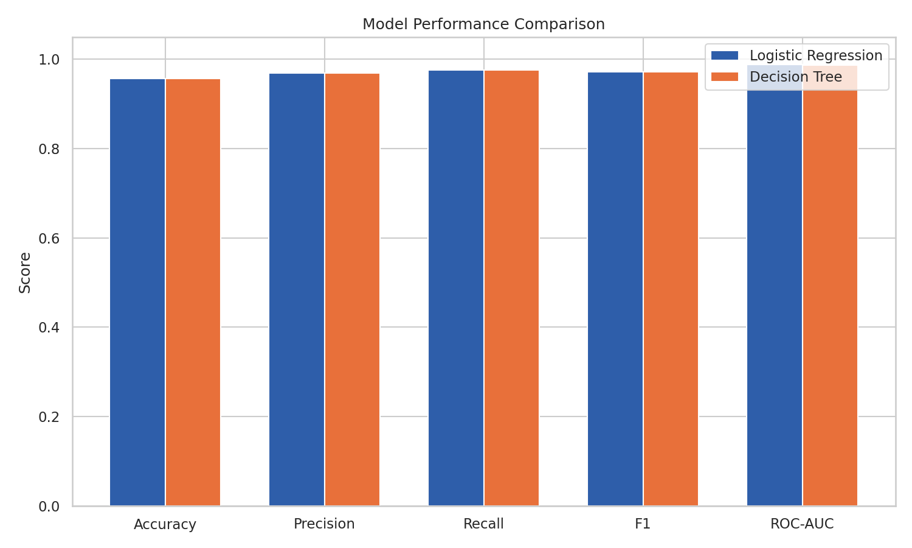
Figure 1. Side-by-side comparison of both models across five metrics.
Both models land at almost exactly the same performance, which was actually a bit surprising — I expected the tree to either underfit (since it's capped at depth 4) or overfit compared to logistic regression, but they ended up nearly tied. My guess is that's because the relationship between Discount and profitability is so strongly linear/monotonic (which we already saw in Week 3) that a linear model captures it just as well as a tree does.

4.3 Confusion matrix
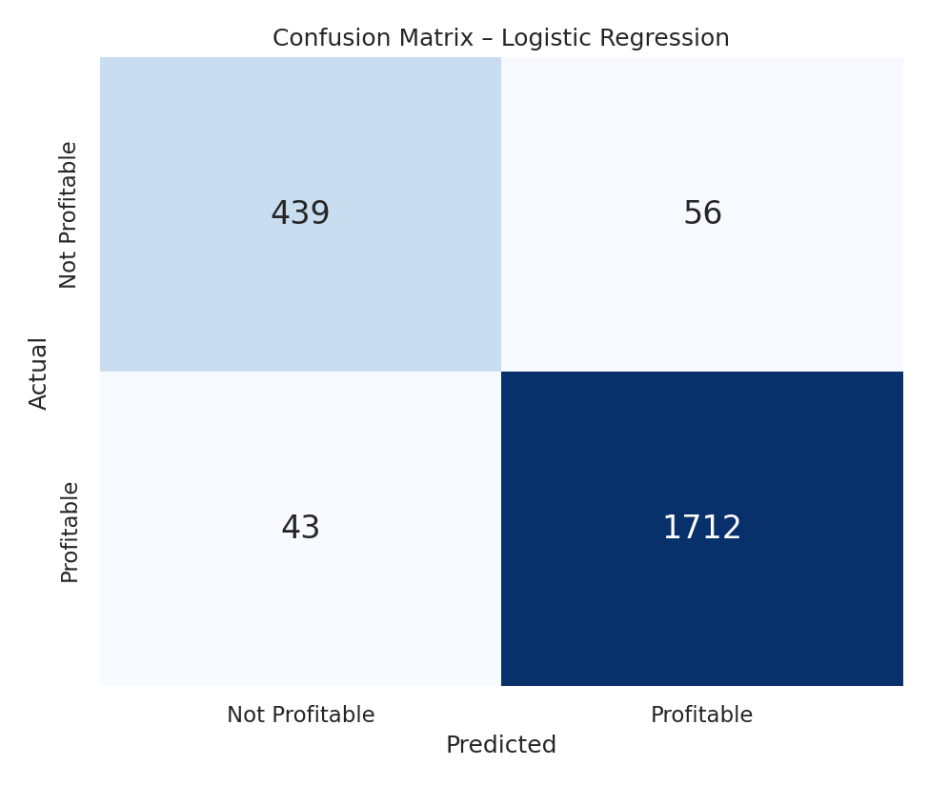
Figure 2. Confusion matrix for the logistic regression model on the test set.
Out of 2,250 test orders, the model correctly identified 1,712 profitable orders and 439 unprofitable ones. It misses 56 profitable orders (false negatives, predicted as not-profitable when they actually were) and 43 unprofitable orders (false positives, predicted profitable when they actually lost money). In a real business setting, false positives are probably the more costly mistake — those are the orders the model would wrongly greenlight as fine, when they're actually losing money.

4.4 ROC curve
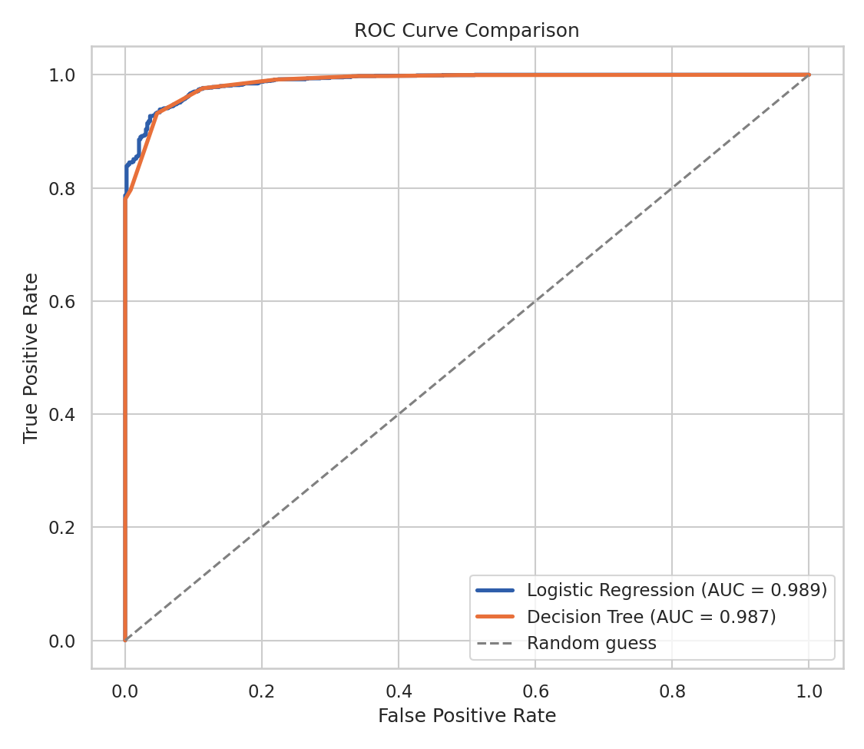
Figure 3. ROC curves for both models. Both sit well above the diagonal ‘random guess’ line.
Both curves hug the top-left corner, and the AUC values (0.989 for logistic regression, 0.987 for the tree) confirm both models are very good at ranking profitable orders above unprofitable ones across basically any threshold you'd pick, not just the default 0.5 cutoff.

4.5 What's actually driving the predictions
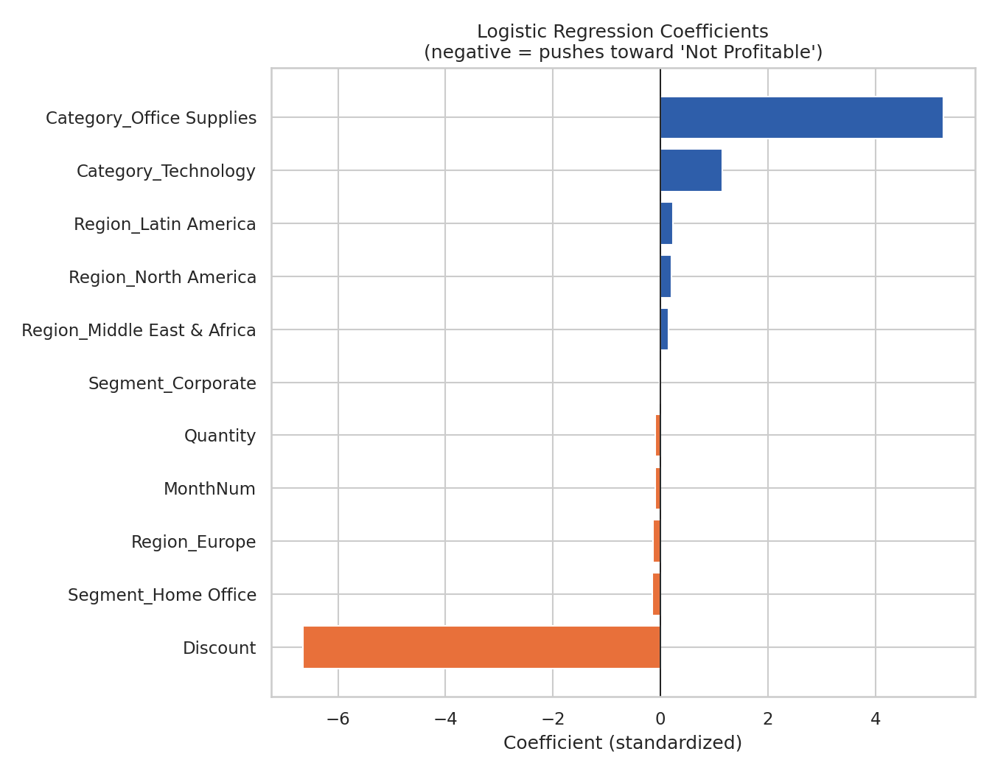
Figure 4. Standardized logistic regression coefficients.
This chart is basically the Week 3 finding showing up again, but now inside a predictive model instead of a hypothesis test: Discount has by far the largest coefficient of any feature, and it's strongly negative — meaning higher discount is the single biggest factor pushing an order toward 'not profitable.' Category also matters (Office Supplies and Technology both push toward profitable relative to the baseline category, Furniture), but nowhere near as much as discount. Region, segment, quantity, and month barely move the needle at all, which is consistent with the non-significant chi-square and ANOVA results from last week.

5. Critical Discussion – Errors, Overfitting, and Improvements

5.1 Sources of error
- Class imbalance (78/22 split) means the model has more examples to learn 'profitable' patterns from than 'not profitable' ones, which is probably part of why recall on the 'Not Profitable' class (0.89) is a bit lower than on 'Profitable' (0.98) — it's the minority class that's harder to catch.
- The features I used are fairly coarse. Real order-level noise (I added random variation when generating the profit values) puts a ceiling on how accurate any model can get, since some of the 'not profitable' outcomes are essentially due to randomness that no feature could predict.
- I didn't include SubCategory as a feature, mainly to keep the one-hot encoded feature space small and interpretable, but it's possible some sub-categories behave differently than their parent category and that's information the model is missing out on.

5.2 Overfitting / underfitting check
I checked training accuracy against test accuracy for both models and they were close (within about 1 percentage point for both), which suggests neither model is overfitting badly. That said, I intentionally capped the tree at depth 4 to avoid overfitting risk in the first place, so this isn't a fully independent check — a deeper, unconstrained tree would be the next thing to try to see how much it overfits versus a shallow one.

5.3 Suggestions for improvement
- Try class-weighting or a resampling method (like SMOTE) to address the class imbalance and see if it improves recall on the minority 'Not Profitable' class specifically.
- Add cross-validation instead of a single train/test split, to get a more reliable estimate of performance rather than relying on one particular 75/25 split.
- Try a slightly more flexible model (e.g. Random Forest or Gradient Boosting) to see if it can pick up on any non-linear interactions between features that logistic regression and a shallow tree might be missing — though given how dominant the Discount feature is, I'd guess the gains would be small.
- Test the model on a real, non-simulated retail dataset to see if the same pattern (discount is the dominant driver of profitability) actually holds outside of this synthetic data, since the synthetic data was generated with discount having a strong built-in effect on profit.

6. Conclusion
Both models perform strongly at predicting whether an order will be profitable, with logistic regression and a shallow decision tree landing within a fraction of a percentage point of each other on every metric (accuracy ~95.6%, ROC-AUC ~0.99). More interesting than the raw performance numbers, though, is that the model's own coefficients independently confirm what the Week 3 hypothesis test already found: discount level is overwhelmingly the strongest driver of whether an order makes or loses money, far more than region, segment, or month.
If I were handing this off as an actual business tool, I'd pair it with a simple rule of thumb rather than relying purely on the model: flag any order with a discount above roughly 25–30% for review before it's approved, since that's the range where both this week's model and last week's statistical test agree profitability starts breaking down. The model adds value on top of that by also weighing in category and the other smaller factors, but discount is clearly doing most of the work.
End of report.

